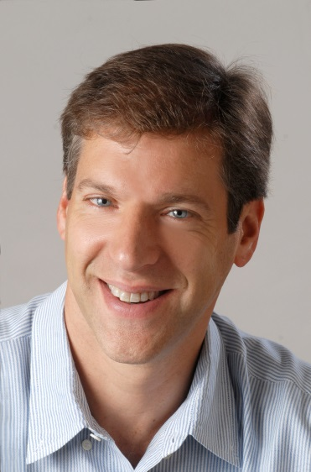

Daniel M. Kammen
Director of Renewable and Appropriate Energy Laboratory (RAEL)
Professor in the Energy and Resources Group (ERG)
Professor of Public Policy Goldman School of Public Policy
Class of '35 Distinguished Chair in Energy University of California, Berkeley
Dr. Kammen is the Class of 1935 Distinguished Professor of Energy at the University of California, Berkeley, with parallel appointments in the Energy and Resources Group, the Goldman School of Public Policy, and the department of Nuclear Engineering. He was appointed the first Environment and Climate Partnership for the Americas (ECPA) Fellow by Secretary of State Hilary R. Clinton in April 2010.
Kammen is the founding director of the Renewable and Appropriate Energy Laboratory (RAEL), Co-Director of the Berkeley Institute of the Environment, and Director of the Transportation Sustainability Research Center. He has founded or is on the board of over 10 companies, and has served the State of California and US federal government in expert and advisory capacities.
Dr. Kammen was educated in physics at Cornell and Harvard, and held postdoctoral positions at the California Institute of Technology and Harvard. He was Assistant Professor and Chair of the Science, Technology and Environmental Policy Program at the Woodrow Wilson School at Princeton University before moving to the University of California, Berkeley. Dr. Kammen has served as a contributing or coordinating lead author on various reports of the Intergovernmental Panel on Climate Change since 1999. The IPCC shared the 2007 Nobel Peace Prize. He serves on the Advisory Committee for Energy & Environment for the X-Prize Foundation.
During 2010-2011 Kammen served as the World Bank Group’s Chief Technical Specialist for Renewable Energy and Energy Efficiency. He was appointed to this newly-created position in October 2010, in which he provided strategic leadership on policy, technical, and operational fronts. The aim is to enhance the operational impact of the Bank’s renewable energy and energy efficiency activities while expanding the institution’s role as an enabler of global dialogue on moving energy development to a cleaner and more sustainable pathway.
He has authored or co-authored 12 books, written more than 300 peer-reviewed journal publications, testified more than 40 times to U.S. state and federal congressional briefings, and has provided various governments with more than 50 technical reports. Dr. Kammen also served for many years on the Technical Review Board of the Global Environment Facility. He is a frequent contributor to or commentator in international news media, including Newsweek, Time, The New York Times, The Guardian, and The Financial Times. Kammen has appeared on 60 Minutes (twice), Nova, Frontline, and hosted the six-part Discovery Channel series Ecopolis. Dr. Kammen is a Permanent Fellow of the African Academy of Sciences, a fellow of the American Physical Society. In the US, he serves on two National Academy of Sciences boards and panels.

